stbenedict.co.uk

The Calming of the Storm

‘That day when evening came, he said to his disciples, “Let us go over to the other side.” Leaving the crowd behind, they took him along, just as he was, in the boat. There were also other boats with him. A furious squall came up, and the waves broke over the boat, so that it was nearly swamped. Jesus was in the stern, sleeping on a cushion. The disciples woke him and said to him “Teacher, don’t you care if we drown?”
He got up, rebuked the wind and said to the waves “Be quiet! Be still!” Then the wind died down, and it was completely calm. He said to his disciples “Why are you so afraid? Do you still have no faith?”
They were terrified, and asked each other “Who is this, whom even the wind and waves obey?”
(Mark 4:35)

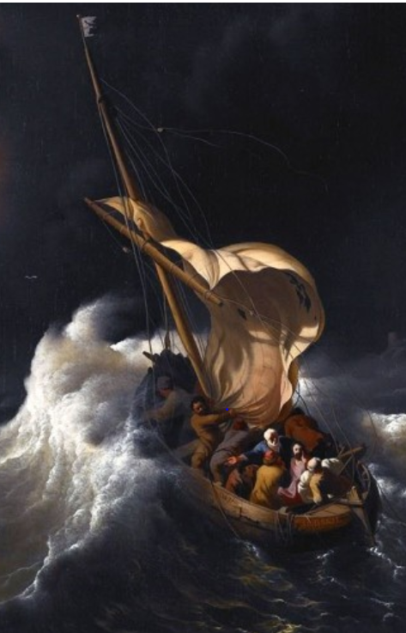
‘Christ in the Storm on the Sea of Galilee’ (Ludolf Backhuysen)

First, some background. The Sea of Galilee is seven miles across, and 700 feet below sea level. To set out at night is no easy undertaking, as any fisherman would know. A word from bibleplaces.com:
“The peaceful calm of the Sea of Galilee can quickly become transformed by a violent storm. Winds funnel through the east-west aligned Galilee hill country and stir up the waters quickly. More violent are the winds that come off the hills of the Golan Heights to the east. Trapped in the basin, the winds can be deadly to fishermen. A storm in March 1992 sent waves 10 feet high crashing into downtown Tiberias, causing significant damage.”
The opening line of the story tells us that what happened was on the evening of ‘that same day’ – a long day of preaching, opposition and danger. As evening came, perhaps the disciples just expected a meal of fish by the lakeside, and some much-needed rest.
But no - when evening came, Jesus tells them to get into the boat and set off across the lake. No explanations; this is no fishing trip. No suggestion that he is going to preach in a town on the opposite side. The disciples took him “just as he was”, with no supplies, no preparation.
Even the most dedicated disciples must have been questioning the wisdom of this, thinking about food, wine and sleep, perhaps, rather than heading out into danger.
When they set out, their fears are realised. It begins to blow a gale, and the waves break into the boat. Mark’s account is typically sparse, but just take a moment to imagine the situation. Wind shrieking in the rigging, huge waves swamping the vessel; the disciples desperately knotting broken lines, and trying to keep at least a scrap of sail on the mast, to give them steerage; their desperate bailing a pointless endeavour, with every gallon ejected from the boat soon replaced by another wall of water.
Soaked, cold and exhausted, when they look back at their Master in the stern of the boat for reassurance, what do they see? There is Jesus, not just asleep, but somehow in relative comfort, on a cushion. How did they feel? How would you have felt?
Their words, shouted above the wind, say it all – “Master, do you not care if we drown?”
When we hear readings in church they are often delivered in a flat, respectful, rather ‘churchy’ way. But these are the words of men fighting for survival, their master appearing to abandon them. Now hear the anger and frustration in those words, “Master, do you not care?” (Matthew and Luke, in their later versions, remove these stinging words, perhaps embarrassed by the raw anger on display towards Jesus.)
Finally, the response of Jesus seems to add insult to injury. He calls out to the wind and waves, stilling them with his voice, and then turns to the disciples and demands to know why they are afraid – have they still no faith?
Take a moment to ask yourself how you would have felt, on hearing that. Surely, mixed with your feelings of relief on being saved, you would have felt mounting anger, and would have to bite back the words ‘How dare you?’
Why did Jesus do it? Leading them into danger, appearing to sleep in comfort while they fought for their lives - and for his - and then rebuke them for their lack of faith? Perhaps they were never in any danger - he was with them, and they were wrong to be afraid. Maybe this was just another demonstration of his identity, his power. But if they were in no danger, why did Jesus calm the storm, rather than tell them not to worry, that with faith in him, they would come through the storm safely?
Mark does not tell us how long the disciples battled the storm, only telling us that the disciples were awake, and Jesus asleep. This suggests that they tried to deal with the situation themselves. They relied on their own strength and skill to get them out of their predicament. It is only when all hope appeared to be lost, exhausted and facing death, that they woke the sleeping Jesus. They treated him as their insurance policy, to be turned to only if all else fails.
So perhaps the story is really about our pride. We only think of turning to God when things look desperate. Until we reach crisis point we would rather not acknowledge our need for God. The boat in the story is us, and the voyage, our life. As we pass through the storms of our lives, do we leave Jesus asleep within us, or do we call out to him?
When Jesus rebukes the disciples, he is telling them that he should not be their last resort. True, he is the eye of the storm, the one place where the howling winds are stilled. But true faith involves turning to him in good times and in bad, on waking in the morning, and when falling asleep. Elsewhere in the gospels we are told that we must enter into a lasting union with him, like a branch of the true vine. He has come so that we can have fullness of life, a share in the kingdom of God. A marriage is on offer, not a fair-weather friendship.
This is the metanoia which Jesus demands, the complete conversion of mind and heart.

Mackenzie Robinson Obl. OSB
18 May 2021

