St Benedict South-West

The Art of Holy Week
Holy Week 2019

Why are paintings of the Resurrection so often rather inadequate, or even inadvertently comical? So often they seem to involve tombs being blown apart in a flash of light, masonry flying, Roman soldiers flinching away from a very bodily Jesus, ascending heavenwards.
The obvious answer is that the Resurrection was an event hidden from human view, a spiritual event which occurred at a time only known to God, in the darkness before dawn on Easter Sunday.
The Crucifixion, on the other hand, was a very bodily scene, involving the kind of bloodstained cruelty with which this world, and the artists who work in it, are sadly only too familiar.

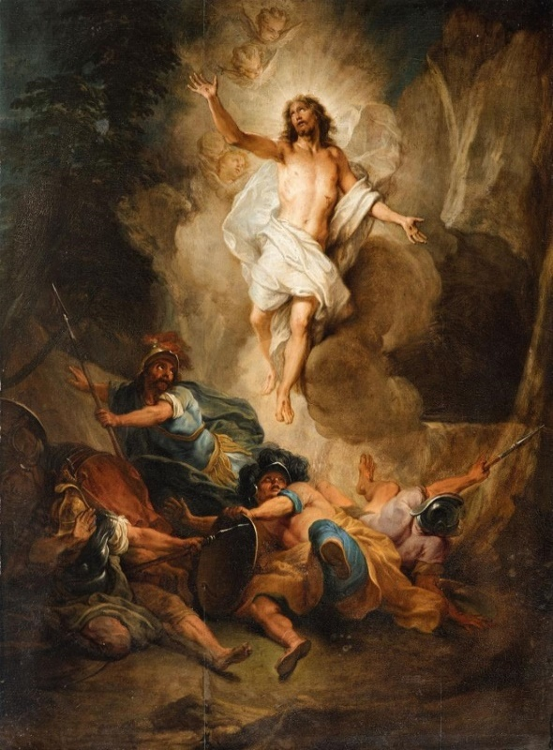
Nicholas Bertin,
‘The Resurrection of Christ’

But perhaps there is another reason why attempts to capture the Resurrection in art often fail.
Visual artists, even the great masters, are very skilled at capturing a moment in time, but the Resurrection is not a stand-alone event. It was not that Jesus, having died, was just somehow found alive again. As Jeremy Driscoll OSB puts it, our Lord has risen from the dead - it is through his dying that we encounter his rising.
The Resurrection somehow contains within it the events which led to it - Christ’s Passion is still present within the Resurrection, as Jesus demonstrated to St Thomas in a graphic, physical way.
Of course artists have attempted to acknowledge this truth by showing the risen Christ with nail marks in His hands and feet, but the reminders of His Passion tend to be glossed over by the artist, understandably concerned to portray the light and hope of the moment of His rising.
Interestingly, the Shroud of Turin, when seen as an artwork (whether human or divine in origin), does not do this. Mysteriously, the fact of the Resurrection is only hinted at in the Shroud image - how else could the image have been ‘flashed’ onto the cloth? But the image itself is one of great suffering, the end of life, with our Lord’s face beaten and battered, eyes closed in death.

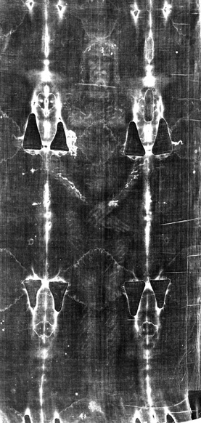

But even if the best paintings of the Resurrection fail to capture the true depth of the event, the way in which they were painted might give us a clue.
Painting in oils is a skilled affair, pictures being built up in layers, taking weeks or months to finish.
Even an area of a painting which will eventually be light and bright, such as the face of the Girl with the Pearl Earring, will have had a

very different genesis. The artist will have started with much darker colours to provide a base layer for the vivid tones we see in the final painting.

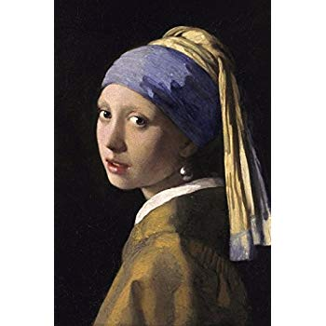
Girl with the Pearl Earring,
Johannes Vermeer

What is less well known is that the subsequent layers of lighter coloured paint are gradually more opaque and translucent, so that when we look at the face of the girl, we are actually seeing the darker base layer through the lighter glazes. When people comment with astonishment how the picture seems to have depth, they are more right than they know.

Perhaps this is a good way of understanding the true nature of the Resurrection. We should understand that the joyful light of the Resurrection contains within it the darker events which necessarily led to it. Just as in the painting of a great master, the Resurrection is not a single event in time, but rather the final translucent finish, the previous layers of the divine brushwork visible through it, combining to make one rich, subtle, bittersweet whole.
As suggested by the title of Luke Bell OSB’s book, the Christian life involves living out ‘A Deep and Subtle Joy’. The Resurrection is not the work of an amateur, dabbling in primary colours.

_____________

The way in which we progress through Holy Week is like the way an artist applies layers of oil paint, building up from dark to translucent light. We do not simply have a Mass on Easter Sunday, in which the terrible events leading up the Resurrection are assumed, or just hinted at. Instead, as the days pass, we enter fully into the shame of Judas’s betrayal, the darkness of the Garden of Gethsemane, and the torture and crucifixion of Christ.
The terrible drama is played out slowly, as if leaving the canvas to dry before applying the next glaze. By the time Easter Sunday arrives, we are steeped in the experience as in a chiaroscuro scene, the light only making sense because of the surrounding dark.

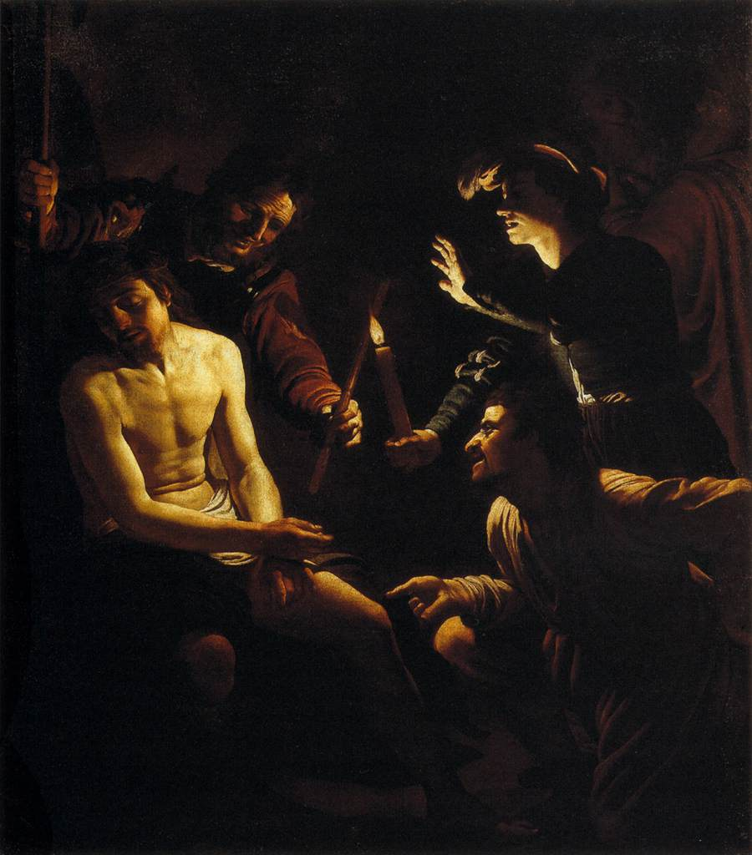
‘The Mocking of Christ’
Gerard van Honthorst
(example of chiaroscuro)

But of course Holy Week is not simply a great drama that we view from a detached standpoint, admiring the way in which the Artist moves from darkness to light. We are expected to enter into it, to become part of the scene itself. We hope, with an accompanying feeling of dread, to find ourselves in the situation described by St Paul in his Letter to the Romans: “I have been crucified with Christ, and now it is no longer I that live, but Christ who lives within me.”
Attaining this level of interpenetration with Christ’s Passion is one of the greatest and most troubling mysteries of the Christian life. But perhaps studying the way in which an artist works with oils can, once again, help us.
Before the artist even begins to apply any pigments to the canvas, he must first prepare the cloth. A substance called gesso, a mixture of binding medium and chalk, is applied in thin layers to the canvas. This resembles a thin white paint, which provides a textured and absorbent base upon which the oil paints can do their work.
Applying this gesso is an art in itself, with not just one layer, or even two or three, but sometimes more than ten layers being applied before the artist can even start his creative work.
The equivalent in the spiritual life would be time spent in meditation and contemplation, bringing quiet to the mind, in order to make ourselves receptive to receiving the vivid colours, both dark and light, of Holy Week. We need to spend time preparing the canvas of our hearts and minds if we are to have any hope of the Artist creating a lasting impression on us. This is not a quick process – each layer of spiritual gesso must be left to dry before the next can be applied.
(Of course it is actually the work of the Holy Spirit within us, not our achievement – ‘We do not even know how to pray, but the Spirit prays within us, deeper than words…’ – St Paul again. We just create the space within us for the Spirit to be at work.)
This is why we take 40 long days during Lent to do what we can (family permitting!) to quieten our minds, and experience the possibility of not being driven by our instinctive needs and desires. Christ is knocking at the door, and if we are to hear his gentle knock, the busy-ness of our household must be stilled.
To fully enter into the events of Holy Week, and feel that we are somehow participating in Christ’s Passion is hard enough. But the final stage is perhaps the most difficult. This is to realise that the darkness and light of Christ’s final moments will find their repeat in our everyday lives. At some point, all of us will experience layer upon layer of thick, dark pigment being applied to our lives, and it is easy to conclude that the portrait of our life will be a bleak one. We need to take heart from the example given us by Jesus, and have faith that the darkness in our lives is a necessary base layer upon which God will eventually work in more beautiful, vivid tones. The darkness will always show through, but that is the way it must be. The brighter colours only obtain their depth and richness from the darker tones still visible underneath. The Resurrection gives us an expectation of joy, but our joy must be deep and subtle, a rich blend of all our hopes and fears, triumphs and disasters.

Mackenzie Robinson, Obl.OSB
19 February 2019
