stbenedict.co.uk

The Labyrinth of Meditation

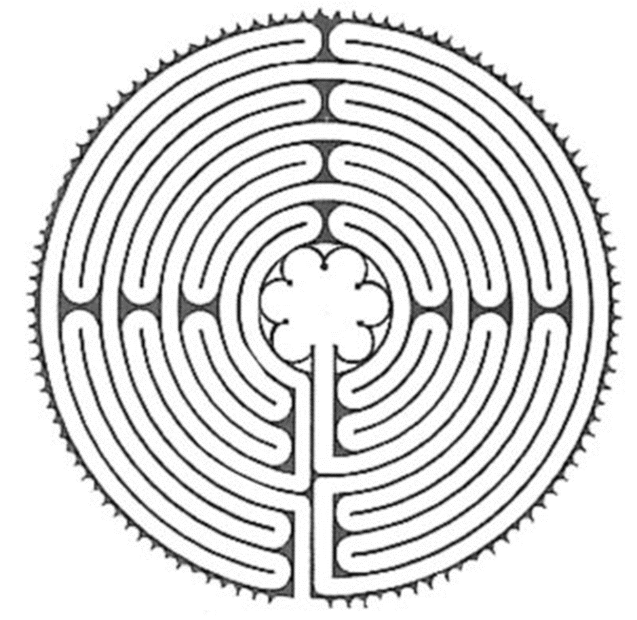
The Labyrinth of the Cathedral of Chartres

You will all have heard of this famous Labyrinth which is laid out in the tiles of the floor of Chartres Cathedral. Pilgrims who could not travel to distant pilgrimage sites would instead make their way to the centre of the Labyrinth on their knees. Apparently the position of the Labyrinth is such that, at the right time of day, the sunlight shining through the beautiful rose window exactly fits the shape of the Labyrinth, filling it with the colours of the window and emphasising the spiritual nature of the journey undertaken by the pilgrims.
Before you carry on reading this, take a pen and trace the required route to the centre of the Labyrinth, marking the route as you go.
_________________

Of course the design of the Labyrinth was carefully planned to emphasise something about the nature of pilgrimage, and the labours of the spiritual journey.
However I would like to use the Labyrinth to emphasise some important lessons about the inner, meditative pilgrimage.
Firstly, note how the design of the Labyrinth encourages those who enter it to think that they will rapidly arrive at the centre, only to find themselves repelled just as they are approaching it, forcing them down a series of switchback curves, leading away from the centre. Then once again the path takes you tantalisingly close, only to veer off at the last second.
This reminds us of one of the most important, and most difficult, lessons we have to learn in meditation - that if we try too hard to arrive at the centre - the centre of our being, which exists below the level of our everyday thoughts - we will actually find ourselves moving away from the centre, trapped in the very thoughts that we are trying to escape. Meditation actually involves the opposite of effort – it is a resting in the presence of the indwelling God, being rather than doing. The more we grit our teeth and furrow our brow in our efforts to not think, the more we end up thinking. Furthermore, our sense of disappointment and frustration that our efforts to be still have not been successful are simply another kind of thought. It is like being trapped in a fairground hall of mirrors.
The answer is simplicity. Meditation takes seriously the realisation expressed by St Paul that ‘we do not even know how to pray, but the Spirit prays within us, deeper than words’. There is nothing we can do to generate an experience of God - we must simply sit in the simplicity of silence, staying with our word, patiently waiting. Sometimes our times of meditation are difficult and frustrating, sometimes they are peaceful and refreshing. Occasionally something more happens, and we experience leaving self-consciousness behind for a while (or at least we realise that this has happened, as we ‘come out of it’, like a diver returning to the surface), and experience something beyond our usual limited vision. This experience of ‘peace such as the world cannot give’ is not the result of our meditation, obtained by our skilful efforts - it is a gift of grace, given to us when we are ready to receive it.
The patience which meditation requires, and the capacity not to be frustrated by experiencing distractions, is also emphasised by the design of the Labyrinth. The initial euphoria we felt, when we appeared to be heading straight towards the centre, is soon replaced by the tedium and frustration of following that series of switchback curves, with no end in sight. Glancing over our shoulder at the centre of the Labyrinth, where what we desire is to be found, only makes the experience more frustrating. Instead we should just concentrate on shuffling forward, one knee at a time, just saying our word, not expecting anything at all. Expectancy is just another subtle kind of thought, and we want to go deeper than that, below the surface, where the wind and waves of our distracted mind have no effect upon us.
At times it can be difficult to continue with meditation, finding the time and willpower to carry on, when nothing seems to be happening. This is like the experience of the pilgrim who finds himself on the outside track of the Labyrinth. The further we find ourselves from the centre, the longer and more unvarying the path becomes. This is the stage which requires faith - trust and confidence that if we keep saying our word in silence, it will eventually be worthwhile. We are waiting on the Lord, and he will not be hurried.
The final part of the Labyrinth, which brings us to the centre, surprises us by its directness, and the speed with which we are led to the centre. It is as if our patience, tested by the wearying loops and false hopes of the earlier stages, is now being rewarded.
This corresponds very closely with the experience of meditation. If you sit for 20 minutes, patiently staying with your word, letting distracting thoughts go, you will usually find that the first 15 minutes are quite unproductive. Distractions come thick and fast, and your efforts to come back to your word need to be repeated again and again. Just when you think that the entire 20 minutes is going to be a waste of time, you may suddenly find that you are ‘coming up to the surface’, having descended to the peaceful depths of quiet contemplation without realising it. It seems to be an experience which can happen quite quickly, without any effort required by us, other than patiently staying with our word and waiting.
This is why we sit for 20 minutes, and not 5, or 10. There are no shortcuts. This is also reflected in the design of a labyrinth. It is not a maze, which would have false trails and dead ends. It is possible to be permanently lost in a maze, looking for the correct route - as the watchman at Hampton Court will tell you, as he enters the maze to rescue another poor soul. The reason I asked you to mark out the route you took with a pen is to demonstrate that there is only one path in a labyrinth - and you have to follow this one path along its entire route before you reach the centre. It is necessary to bear with the disappointments and tedium that the route takes in its journey to the centre, but that is just what prayer, and life, is like.
It’s worth it when you arrive, though…

Mackenzie Robinson, Obl. OSB.
5 August 2019

