stbenedict.co.uk
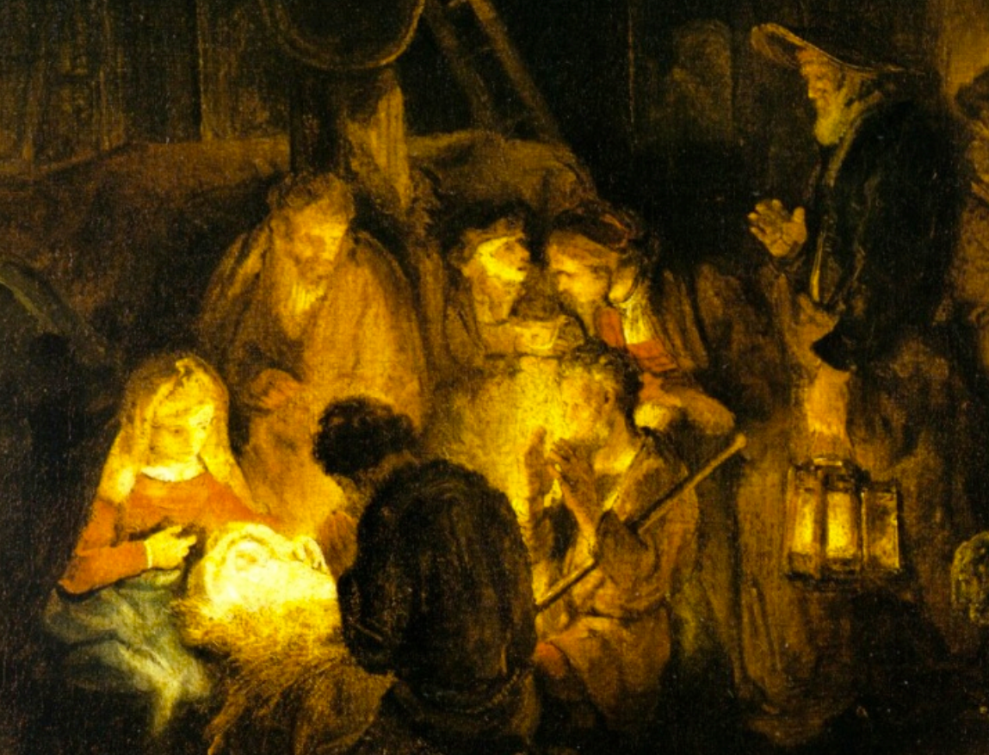
‘Adoration of the Shepherds’ - Rembrandt

Advent with Alyosha

A curious thing about The Brothers Karamazov is that the hero does so little.
In the introduction, Dostoevsky makes it clear that the youngest brother, the pure hearted Alyosha, really is the hero of the novel. He is named after Dostoevsky’s own son, who died in infancy – surely he represents everything Dostoevsky hoped for.
Alyosha begins as a monastic novice, and his commitment to Christ kindles within him the virtues of faith, hope and love. These not only keep him on the straight path when others are losing their way, but also open the eyes of his heart to heaven, breaking through everyday things. The chapter ‘Cana in Galilee’ is one of the most beautiful passages of any book I know.
But it is his two brothers, the intellectual Ivan and the wild spirited Dmitri, who drive all the action. Alyosha seems confined to a supporting role. Why?
The answer becomes clear when we step back and look at the way that the drama works in the novel as a whole. The actions of Ivan and Dmitri are thrown into sharp relief by the light that Alyosha provides. He is like the source of light in a chiaroscuro painting. The infant Jesus in the crib, in Rembrandt’s Adoration of Shepherds, is doing nothing - but without his presence the shepherds would be dull, aimless figures, rather than finding themselves like moths attracted to a flame. Their actions are driven by the one who does nothing but radiate love.
But as we read on, we have no great hope for Ivan and Dmitri, who seem hell-bent on their own destruction. We are desperate not to see Alyosha become disillusioned, and lose faith by just being around them. He is the bringer of hope – so why can’t Alyosha save his brothers, by his loving nature?
Well, for one thing, this is Dostoevsky - if its sugar coated sentimentality you’re after, you’ve come to the wrong shop. He draws from real life, and the Russia of his time was steeped in hardship, which, like the cold, bitter winters, gnawed into the very bones of the people. A tendency to vodka fuelled self-destruction gets more and more ingrained with time, and even those people who are really touched by Alyosha’s loving heart seem unable to turn back from the path that they have taken.
But this tragic tale is ultimately a story of hope. Several times in the book Alyosha encounters a group of young children, who at first seem to be bent on the same reckless and destructive path as the adults around them. When he first finds them, they are engaged in a stone fight, many children against one. Since Dostoevsky’s writing is so steeped in Christian thought, the scene brings to mind the gospel story of the rescue of the woman from stoning – ‘let him who is without sin cast the first stone’. In this case, the children do throw stones, even hitting Alyosha, so perhaps that is a hint that they are ‘without sin’ – at least the hardened, ingrained kind. They behave badly, but it doesn’t yet define their character. Alyosha tries to intervene, and act as peacemaker, and in contrast to the reaction of his older brothers, he is successful, and brings his young ‘disciples’ (twelve in number) to repentance and faith in the resurrection.
Dostoevsky reminds us that there are two paths we can take in life – Ivan’s uncompromising intellectual questioning, and Alyosha’s way of childlike wonder, maintained despite all of the grief and tragedy of the world. (Dimitri, the brother we have not considered, is the third path, of reckless addiction to sensual pleasures - a path that ends in self-destruction, just as surely as Ivan’s.)
Although the first path seems honest, at least, it can lead us away from God. Dostoevsky reminds us of the teaching of Jesus, that only if we approach life with the simplicity and wonder of a child will we enter the kingdom of heaven. The adults in the story, too deep in the habitual pits that they have dug for themselves, seem unable to hear the call of Christ.
Getting through a Dostoevsky novel can feel like a long dark Advent, but it is worth it. No-one else writes with such depth and perception about what it means to be human, and our relationship with God – and in Alyosha he reminds us of what we could all be like, if our faith had this innocent, trusting quality. Despite the darkness surrounding him, he brings light and hope. Those wonderful words of Isaiah spring to mind: ‘The people who walked in darkness have seen a great light; those who dwelt in a land of deep darkness, on them has light shone.’
As we pass through Advent, waiting in the wintry darkness, separated from each other by isolated and infection, let us remember Alyosha, and his unbreaking trust that all will be well in the end. Something promised has not yet arrived, and we must wait for it with childlike anticipation. It is, after all, a child that we are waiting for.

Mackenzie Robinson Obl. OSB
13 December 2020

