stbenedict.co.uk

The Good Judge

I have always struggled to connect the cross of Christ to my life, in the here and now. How did his suffering achieve what is claimed? Exactly how did it take away our sin, my sin?
Perhaps the image of the crucified Christ is one which has become too familiar to us. How many times, from early childhood, have I seen a crucifix or a painting of the crucifixion, so that even such a shocking event does not shake me awake as it should?
As someone who has spent far too many years in the criminal courts, I have come to realise that the story can be told in a new way, to help us see it again with fresh eyes.
____________

Monday morning, Court No. 1, and the public gallery is packed. Members of a criminal gang have been found guilty of a long list of crimes, and are due to be sentenced. Each crime is nothing out of the ordinary - burglary, assault, robbery - but the sheer number of offences, and the long period

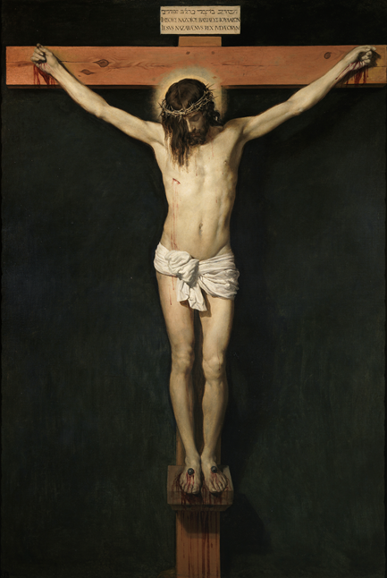

of time over which they were committed, make long prison sentences likely.
The defendant’s hopes are raised when they see the judge. He is known for being quite soft - but he soon dispels that hope.

“Your crimes are so many, and so serious, that only a long period of imprisonment will suffice.”
Heads begin to hang in the dock, an atmosphere of sullen anger developing.
“The sentence for your crimes will be an indeterminate time in prison, to be released only when judged safe.”
The judge pauses for a time, silence in court.
“But you will not serve the sentences. I will. Instead of you.”
The silence continues, an atmosphere of blank incomprehension in court. It is only as the judge directs the security staff to handcuff him, and he is led down to the cells, that pandemonium breaks out. Gasps of disbelief, shouts of outrage, a mixture of laughter and bewilderment in the dock.
Court staff release the defendants from the dock, and they really are free, to go home.
The majority immediately go out and celebrate their unbelievable luck, by getting as drunk as possible. By midnight, several assaults have occurred, a late-night shop owner is robbed, and two houses burgled.
But not all react in that way. One goes home to his empty flat, and just sits staring at the wall, lost in his thoughts. Why did he do it? The hours pass, the sun sets, night falls. Still no answer, he remains wrapped in his thoughts, unable to let it go.
No great believer in justice himself, he nevertheless recognises that this is injustice. They had committed many crimes, and could hardly complain about being punished. But an innocent man going to prison instead, and a judge at that - what could that possibly achieve?
All of the possible explanations fall flat, come up short. In the end, approaching midnight, a nagging thought that will not go away is the only thing that remains. Impossible to believe, outrageous, but the only thing that makes any sense: the judge must have done it out of love - love for them, hardened criminals though they are.
As this truth sinks in, it feels like water pressing at a crack in a dam, and eventually something gives. A warmth in his heart becomes somehow unbearable, and tears flow, washing away years of hurt and guilt. Feeling a sense of joy, but also utterly spent, he finally sleeps.
Waking in his chair next morning, he feels an incredible lightness of being. Friends look at him strangely, and ask if he is all right, but no words come. No words can express what is in his heart.
On the third day after the hearing he is woken early. A phone call from a friend, talking quickly, excitedly. “He’s out – he’s been released - no one knows where he is.”
Rumours fly. There is talk of his cellmate waking up and finding him gone, just his prison clothes neatly folded on his bunk. People say he had been badly beaten by other prisoners, and had to be moved elsewhere for his safety.
By midday the truth emerges. He had indeed been assaulted by fellow prisoners, a savage attack which had left him with many injuries. The Lord Chief Justice, fully aware of his innocence, had intervened, and directed his immediate release, using powers reserved to him.
Then came the news that he had been reinstated, with his full powers as a judge, and letters were being sent out, inviting them all back to court. No summons this time – attendance voluntary.
When he arrives, he is alone.
The judge soon dispels any notion that it had all been a trick.
“I told you that you would not serve the sentence for the crimes that you had committed, and I meant it. My three days, in that hell of a prison, bought your freedom. I served your sentence for you.
Looking at him from the public gallery (no dock this time), seeing his injuries, the feeling wells up within him again.
“Do you know why I did it?”
The defendant nods, unable to speak. The judge looks at him, and he knows - and the defendant knows that he knows.
“I can see what is within you. I can feel the gratitude, the relief of a burden lifted. I can even feel – yes - even love.”
The defendant nods, dumbly.
“But to love someone who has shown you love - that is the easy part, I am afraid. I have called you here for a different reason. Will you do something for me?”
What can I do for this judge, he thinks. I have nothing that he could possibly want. But once again, he nods, and finds himself able to speak – “Anything.”
“Go out there.” The judge motions to the courtroom door. “Go out there, and do as I have done. Show love to those who have shown you none. Will you do that for me?”
The defendant bows his head, still feeling unworthy of what he has been given, and unsure he can fulfil the judge’s request. But then he remembers the full truth of what has happened, the realisation that he has received mercy - undeserved, unconditional love.
Raising his head, he hears the words coming out of him - “I will.”
Walking out of the courtroom, he can hardly feel the weight of his own footsteps. Breathing in the cold air on the steps of the court, he finally allows himself to hear the truth –
“I have been given new life.”

Mackenzie Robinson Obl. OSB
13 May 2021

