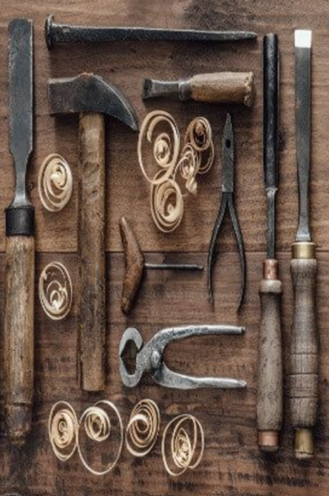
stbenedict.co.uk
The Tools of Good Works

It’s easy to approve of gospel values in the abstract. But when you try to live them out, it becomes more difficult. “I love humanity”, said Linus in the cartoon strip ‘Peanuts’. “It’s just people I can’t stand”.
The Rule of St Benedict is unique because it is a practical guide to living out the values of the gospel in community. It has endured for over 1500 years because it works in any community - families, parishes - not just cloistered monasteries.
Chapter 4 of the Rule, ‘The Tools for Good Works’ appears to be a complete summary of the values of the gospel. As such, it makes rather daunting reading – seventy or so moral and spiritual commands. If this is what holiness requires, I might as well give up now, surely…?
But St Benedict describes his text as ‘this little rule that we have written for beginners’. In the Prologue he

says ‘we hope to set down nothing harsh, nothing burdensome…do not be daunted immediately by fear and run away from the road that leads to salvation.’
So how are we to understand Chapter 4 of the Rule, which at first sight does look so daunting?
The key to understanding it is the image that St Benedict uses. He calls these moral and spiritual commands ‘tools’.
I am hopeless at doing things around the house, but even I know that you do not use all your tools at once. You identify which tool is needed for the job, use it, and put it away. Only then do you move on to the next task.
Benedict also reminds us that time is on our side. Learning to live with others is a lifelong task, which is why Chapter 4 ends with the all-important words ‘The workshop where we are to toil faithfully at all these tasks is the enclosure of the monastery and stability in the community.’
You have your whole life to become proficient in the use of these tools. Never be put off attempting something by the time it is going to take. The time will pass anyway. You’re not going anywhere.
The other helpful thing about life in a community is that everyone else is learning to use the same tools. You are not on your own. When you hit your thumb with a hammer, your brother will be on hand with the first aid kit. When you drive the nail through a water pipe in the wall, your sister will turn off the water supply, and reach for the tool to fix the pipe.
Turning to the words of the Rule, if you find that you are ‘grumbling or speaking ill of others’, hopefully the brother whom you have offended will be familiar with using another ‘tool’ - ‘if people curse you, do not curse them back, but bless them instead’. It is reassuring to know that we live in a community where everyone has promised to learn to use the same set of tools, to achieve the aim of the whole community – ‘First of all, love the Lord God with your whole heart, your whole soul and all your strength, and love your neighbour as yourself.’
When we fall, our sister helps us up. When our brother stumbles, we reach out a hand. This is really the essence of the Rule - that it is by mutual love and obedience within the ordinary life of the community that we come closer to Christ.

Mackenzie Robinson, Obl. OSB
2 July 2021

