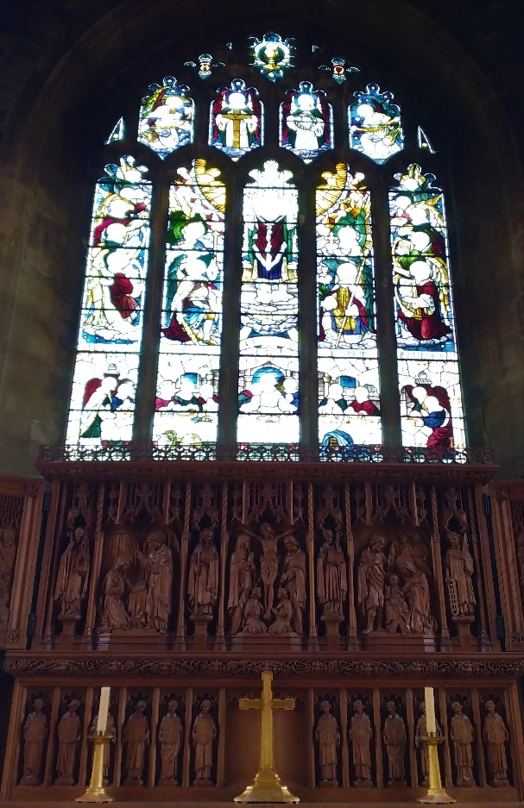
stbenedict.co.uk 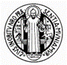
Stained Glass and the Light of Life
It is wonderful to worship in a church with beautiful stained glass. Many churches during the Reformation had their stained glass smashed out, and replaced with plain glass – no distractions from listening to God’s word, read in plain English.
This ignored the fact that people absorb the truth in different ways. Some love music, some are tone deaf; some see, others prefer to listen.
Stained glass windows are not just a pretty sight when the sun floods through them (although I cannot be the only one who takes a childlike delight in their colourful glow). Even when the readings for Sunday are over, the windows remain as an ever-present reminder of the Incarnation, the sacrifice of the Cross and the lives of the saints. A stained glass window is to a plain window what a page of Scripture is to a blank page.

Stained glass windows are a unique form of art, because they actually bring the light to us. Ordinary paintings use light, of course, absorbing most of the spectrum, and reflecting back just the colours of the brushstrokes. But stained glass brings the light in. Imagine if all the windows in our church were paintings on stone walls - what a dark and forbidding place it would be! Instead, the windows light up our times of prayer and worship. The words of the
Prologue to St John’s Gospel come to mind –
‘The light shines in the darkness, and the darkness has not overcome it.’
The light that St John was describing was the logos, the eternal creative Word of God. His life is our light.
Perhaps stained glass can help us to understand the mystery of the Eucharist. No mere symbol, we believe that the bread and wine are the means by which Christ gives himself to us. He is truly present through them, and by him, we are transformed at the deepest level.
Now imagine a stained glass window at night. Does it retain its colours? Is the red glass really red, when there is no light shining through it? Surely, if we could just get close enough, perhaps with a tiny light, just enough to see by…
But that is just the point - without any light, the glass may as well be solid stone. It has no colour unless the light shines through it, briefly transforming its nature. In the same way, when we invoke the Holy Spirit to transform our gifts of bread and wine, they become the means by which the real presence of Christ is transmitted to us. If only we could see the transformation, like a stained glass window shining with the light - let us be given the eyes to see!
But that is not the end of it. If the Eucharist transmits the life of Christ to us, and that life is our light, then we must allow that light to shine through us, out into the world - or at least our small part of it. The windows in our church portray the great saints in our tradition - St Peter, St John, St James, and of course St Andrew. But understand this - by your baptism, you have received the same call. When you receive Christ in the Eucharist, you become one of those windows. Don’t pull the curtains when you leave the church.
It is daunting to think of ourselves in that way. We live very ordinary lives. We may experience moments of deep meaning and joy, such as the arrival of a new baby, but most of our life is not like that, and we are often a disappointment to ourselves.
But look again at the saints in our windows. It is not just those lives that are filled with success that transmit the light of the risen Christ. Those who experience struggle and sorrow also do - perhaps in a more intense way, although it may be difficult to appreciate at the time. As the window above our altar reminds us, the joy of the Resurrection comes to us through the struggle of the Passion. The light of Christ is at work in the darker colours of our lives, as we shall one day see:
‘For now we see through a glass darkly, but then we shall see face to face.’
1 Corinthians, 13:12

Mackenzie Robinson, Obl. OSB
26 May 2021

