St Benedict South-West

Sunday 1st January 2019: Mary , Mother of God
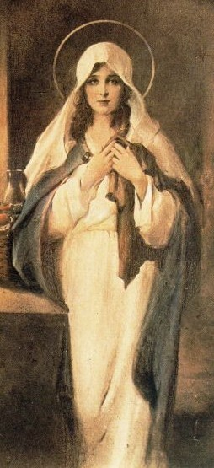
‘The Madonna of the Sacred Coat’
Charles Bosseron Chambers, 1890

Writing about how beautiful landscapes can give us fleeting experiences of joy (see the Advent Reflection) reminded me of an experience I had when I was sixteen.
I was on my own in North Wales, climbing the north ridge of Tryfan, when I stopped for a breather and looked out over the Ogwen Valley. It was one of those beautiful Welsh mountain days, with white clouds drifting across a perfect blue sky. The grass was that almost dazzling green, and I was suddenly filled with a sense of joy at the perfection of what was laid out before me. But after no more than a few seconds, the sense of joy was replaced with a feeling of great sadness, and I could not work out why. Nothing had changed; but try as I might, I could not recover the moment. 32 years later it still haunts me, and I sense that it was one of the important moments of my life.
I am now beginning to see the experience in a new light. My struggle to find God, and feel a sense of presence in prayer, has always been dominated by a feeling of absence. It is like walking into a room that someone has just left. I now see this as linked to my experience on that Welsh mountainside.
We looked at this in the Advent reflection, about how God is unknowable by His very nature, and why the Incarnation is therefore so central, the Son giving us a view of the Father, but only ‘as through a glass darkly’.
Without a faith based on a real relationship with the risen Christ, we can only have occasional tantalising glimpses of what heaven might be like. We can only to be reminded that we are not there yet, denied the full vision. It is like being given a view of a perfect garden through a barred window - we are struck by beauty, and then by its unattainability.
This of course is the story of Adam and Eve, and the Fall. Mankind has been expelled from the Garden, and we cannot find the way back, at least on our own.
Our hope comes in the form of Jesus, the new Adam. He has come to lead us back to the Garden, and our relationship with him will open that gate, rusty through disuse, that leads back to Paradise.
He is our hope, certainly, and indeed, ‘the way, the truth and the life.’ But half blind as we are, we struggle to enter into proper relationship with Christ. We need a guide, someone who will point the way, and keep our feet from stumbling.
This is why Catholics revere Mary so much. She is fully human, like us apart from having been conceived without sin. By learning to look at Christ as she did, seeing her relationship with Him as our something which can inspire us, we have the surest guide. We also believe that, as the greatest of the saints, she is in the presence of God now, and can hear our prayers and intercede for us.
So the next time we are struck by both the beauty and unattainability of a perfect landscape, and we somehow feel the absence of God, we should recall the response of Mary to her Son. We are closer than we think to Christ. Just as she ‘pondered all these things and treasured them in her heart’, her relationship with her Son remains the model for us.
She is the perfect disciple, who shows us how to find the path and stay on it, the path which leads to union with the One who can lead us back to the Garden.

