stbenedict.co.uk 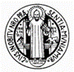

Holy Week 2020

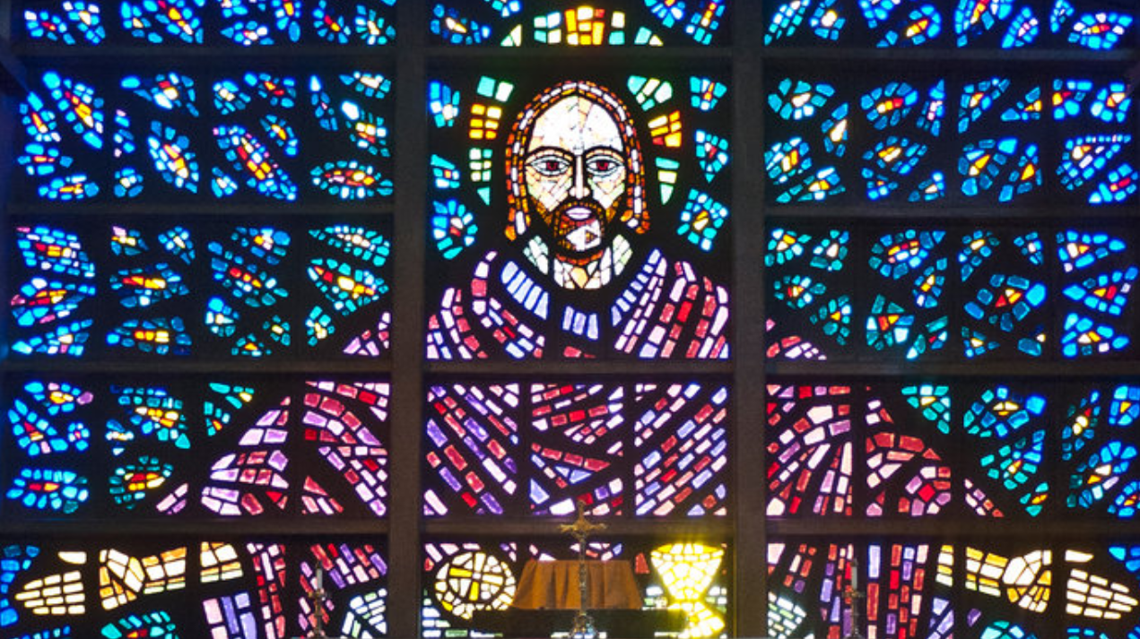

I have written before about how a stained glass window may be a good way of approaching the nature of God’s relationship to his creation - (www.stbenedict.co.uk/reflections - Advent 2018)
The glass itself has no colour or radiance – in the darkness it might as well be solid stone, just like the wall surrounding it. It is only through the action of the light working with it, in it, and through it, that its true nature is revealed. It was created to reveal the light, to be a focus for it. What would otherwise be dull and lifeless is transfigured by the light.
All of creation can be seen in this way, and to those who have the mystical vision, it is. My father, Edward Robinson, who wrote on children’s religious experiences (‘The Original Vision’) had his own mystical experience as a young child. He was taken on a dawn walk, and suddenly saw that all the plants and flowers around him were shining with an inner light - not simply sunlight playing through leaves and flowers, but the divine energy which pervades all life, visible to his inner eye, the gift of a mystical vision. Whether it happened again, I do not know – he never spoke of it to me directly, and I only came across it unexpectedly, years ago, in a book which I have now lost – if anyone knows it, please contact me!
According to this mystical understanding of creation, everything is created to make the love of God manifest - ‘Through him all things came to be, and without him not one thing had its being. In him was life, and that life was the light of all men.’ (The Prologue to the Gospel according to St John). This interconnectedness of all things through Christ enabled St Francis to talk of Brother Sun and Sister Moon – and even Sister Death.
This is easy to see when we watch birds of paradise, or butterflies flitting from flower to flower, but not so easy when we consider the parts of creation which seemed more savage to us. As Blake wondered in his poem, The Tyger – ‘Did he smile, his work to see? Did he who made the lamb make thee?’ The sometimes terrifying variety of creation reminds us of God’s response to Job, that God’s ways are not our ways. Nevertheless, we must trust that everything is the way it is for a reason, even if we cannot perceive it.
In fact, it is us who are the strange ones. Everything else in creation acts in accordance with its given nature. We, on the other hand, have this strange impulse to turn away from the light, to seek comfort in the darkness. Sadly, we do not see it as darkness. We think we can create our own light, like a stained glass window which thinks that it can illumine itself. We pursue wealth, power, fame, placing our trust in the passing things of this world, rather than turning towards the true light. We call this mysterious tendency ‘original sin‘. The most common Greek word for sin in the New Testament is ‘hamartia‘, a term from archery, meaning to ‘miss the mark’, to aim in the wrong direction. If only we could resist this temptation to turn away from the light of Christ, and instead seek our own illumination, all would be well. However, as St Paul famously realised, the thing that we should do is the one thing we fail to do, and we always end up doing the one thing we know we should not. What can be done?
This terrible tendency to turn away from the light, even to try and snuff it out, is on full display in the events of Good Friday. The inhabitants of Jerusalem initially welcome Jesus with open arms, but are soon persuaded to turn on him and crucify him. Even his disciples, for the most part, keep their distance. Nevertheless, his parting words to them are ‘my peace I leave you, my peace I give you - peace such as the world cannot give. So set your troubled hearts at rest, and banish your fears.’ Even after this betrayal, his terrible suffering and death, his first word to his shocked and doubtless terrified disciples is shalom - peace.
The message of Holy Week is that even those of us whose nature it is to turn away from the light - and that is all of us - are continually invited to turn back towards the light, to allow our lives to be a revelation of God’s creative love. No-one is lost, while we have the light of life. Christ came for the lost sheep, the physician for the sick, not the healthy. The loving father is always on his highest rooftop, scanning the horizon for return of his son.
The resurrection of Jesus Christ from the dead is God’s promise that the light will shine in the darkness, and the darkness will never overcome it. We can respond to that grace, we can turn towards the light, and be illumined in Christ.

Mackenzie Robinson, Obl. OSB
Good Friday
Holy Week 2020

