St Benedict South-West

Joy
Sunday 27 January 2019
Readings: Nehemiah 8:2-6, 8-10; Luke 1:1-4 and 4:14-21
Another memory from my childhood holidays in Wales. I must have been no older than twelve, possibly just ten, and I was given freedom by my parents which would be unimaginable now. Every day I was free to wander the hills above the cottage we had rented, with no map or compass (and no ability to use them anyway). There would have been a vague instruction to return in time for dinner, but little more.
In the hills directly above the cottage there was an area of quaking bog, with bright green sphagnum moss and cotton grass waving gently in the breeze. It was another blue sky day, and I was enjoying the way the deep beds of mossy ground were quivering under my feet, when suddenly I plunged through and sank to my waist, and every move took me another inch downwards. My carefree day suddenly turned to horror, and as seconds passed like minutes, I

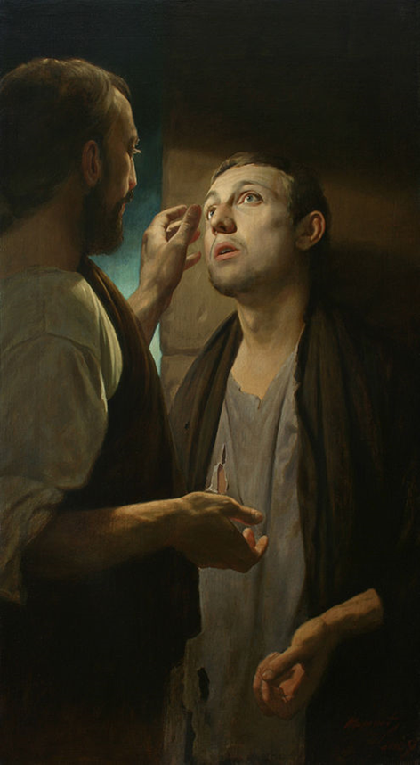
‘Christ and the Pauper. The healing of the Blind Man. ‘
(A.N Mironov.)

genuinely thought I was going to die.
Like anyone in such a situation, I appealed to God in abject fear, making all kinds of promises, if only he would get me out of the situation. I recall promising to open a zoo to save endangered animals – but I am afraid that, like most covenants man makes with God, it was soon broken. He is still waiting for that zoo.
In the end I remembered the advice of my earthly father, to be guided by the colour of the sphagnum moss. Where it is turning red, or even better white, there lies drier land. Managing to haul myself out using a clump of reeds, I managed to find my way out of danger, wisely deciding to mention nothing of this to my parents.
As I started off down the hillside, I was filled with an almost inexpressible joy. Never had the sky seemed so blue, or the grass so green. Simply to be alive was miracle enough.
I was reminded of this when Bishop Mark visited the Priory on Sunday, and told us of how Pope Francis had asked him and his fellow bishops to return to England and remind people to be joyful.
One often hears this - that we are a resurrection people, but our faces rarely seem to show it - so lighten up, and be joyful! Gaudate!
The Pope is quite right, of course, our joy should be visible if we are to be convincing witnesses to the world. But is it that simple? Can one simply decide to be joyful? Perhaps if we celebrated our liturgy a bit more cheerfully, and didn’t dwell on the darker side of things?
I doubt it is that simple. True, divine, joy is quite different to simple happiness. Our readings this week remind us that true joy arises from an experience of being released from something. Ezra the Priest lectures the people from dawn ‘til noon about the strict demands of the law, about fasting and self-denial, but then reminds them that the seventh day which follows is a day of rest, when they could ‘eat the fat, and drink the sweet wine’.
Jesus then breathes new life into the strict demands of the law, telling his followers that true joy will arise from the power of love, lifting people out of their darkness – ‘bring the good news to the poor, proclaim liberty to captives, and to the blind new sight, and set the downtrodden free’.
The reason why ‘the last shall be first’ is that their experience of earthly misery prepares them to see Jesus’ coming passion for what it truly is. The miracles he performs for the blind and the sick are signs that point to what is to come - that his crucifixion and death are the dark soil from which his risen life will spring. As Isaiah reminds us, it is those who have walked in darkness that will see the great light. The tragedy of those who live in comfort and wealth, as Jesus frequently reminds us, is that they do not see their own darkness, and do not seek the light. Wealth brings the illusion that we are insulated from having to seek the help from others, and worse still, from God.
This is why authentic Catholicism is at home when dealing with dark and difficult subjects. The joyful and glorious mysteries of the Rosary are punctuated by the sorrowful mysteries. We must first walk the Stations of the Cross before we are ready for the Resurrection.
_________________

On reading the first draft of this reflection, Fr Guy de Gaynesford asked me to add something, which I think is quite profound: when we experience true joy, the kind of joy we have been discussing here, it is not something that just arises within us, our doing. It is the work of the Holy Spirit, a sign that we are beginning to participate in the divine life. We are actually experiencing what God is like, within himself. A rather wonderful thought.
Of course joy is just one of the nine ways in which the divine life is manifested in us, as described by St Paul in his Letter to the Galatians as the ‘Fruit of the Spirit’: love, joy, peace; patience, kindness, goodness; faithfulness, gentleness and self-control.
Next time we will look further at the Fruit of the Spirit, and what it really means to participate in the divine life.

Mackenzie Robinson, Obl. OSB
21 January 2019

